EX NO:
DATE: CREATINGJIRAACCOUNTFORPROJECT

AIM:
TocreateandconfigureaJiraaccountforprojectmanagementandpracticescrum methodology by planning, tracking, and managing project tasks using scrum boards.

PROCEDURE:

- LogintoJira–AccessyourJiraDashboardandselecttheprojectyouwanttowork on to see all related tasks.
- OpentheBoard–ChooseScrumorKanbantogetavisualviewofallissuesand their current status.
- CreateIssues–Click“Create”toaddEpics,Stories,Tasks,orBugs representing
workitemsfortheproject.
- AddDetails–IncludeSummary,Description,Priority,Assignee,andDueDateso everyone knows the task and timeline.
- OrganizetheBacklog–Prioritizeissuesbasedonimportanceorurgencyforsmooth sprint planning.
- UpdateStatus–MoveissuesacrosscolumnslikeToDo→InProgress→Doneto
trackprogress.
- Collaborate–UseComments,Mentions,andAttachmentstocommunicateandshare information with the team.
- UseCalendarView–Checkduedatesandsprinttimelinestomanagedeadlinesand workloads effectively.
- TrackProgress–ApplyBoards,Filters,andReportslikeBurndownorSprint Reports to monitor project health.
- ResolveandReview–Markissuesasdoneandreviewoverallprogressusing Reports and Dashboards.

PROJECTTASKOVERVIEW:
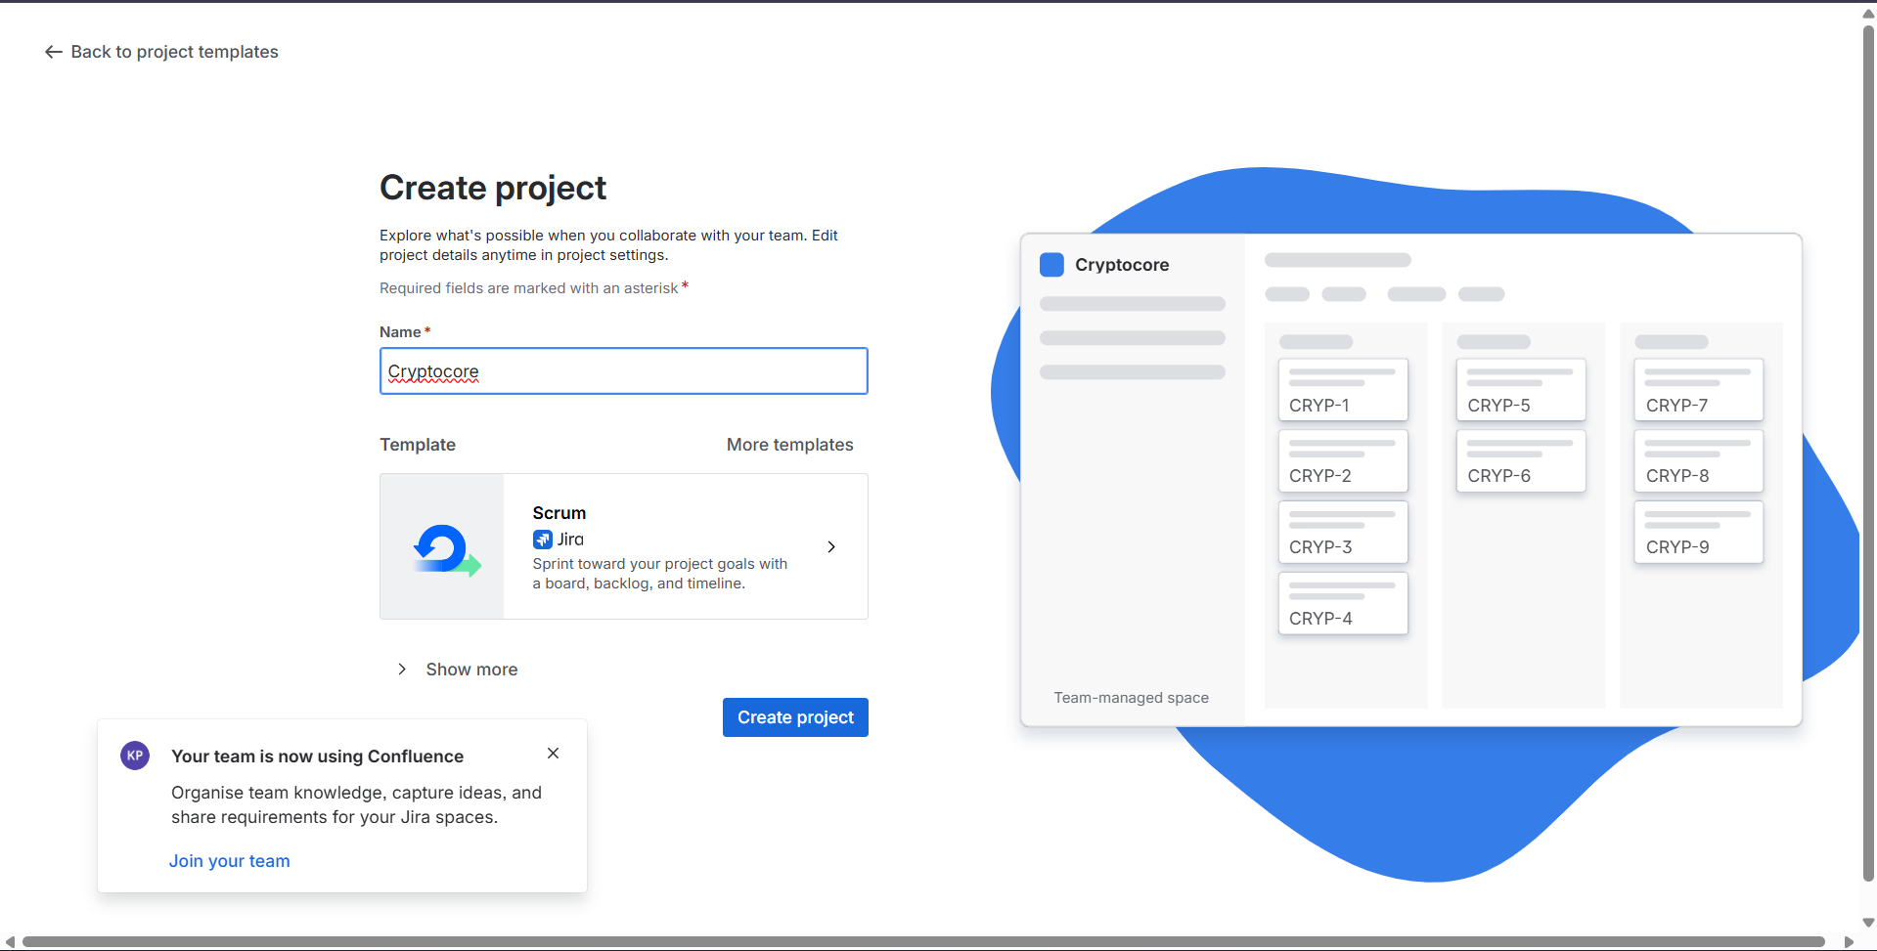

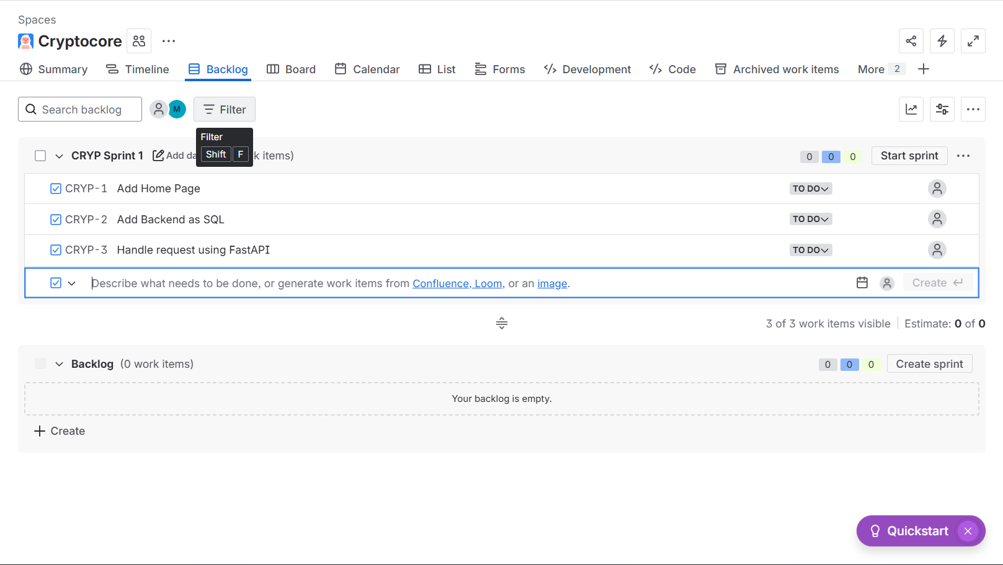

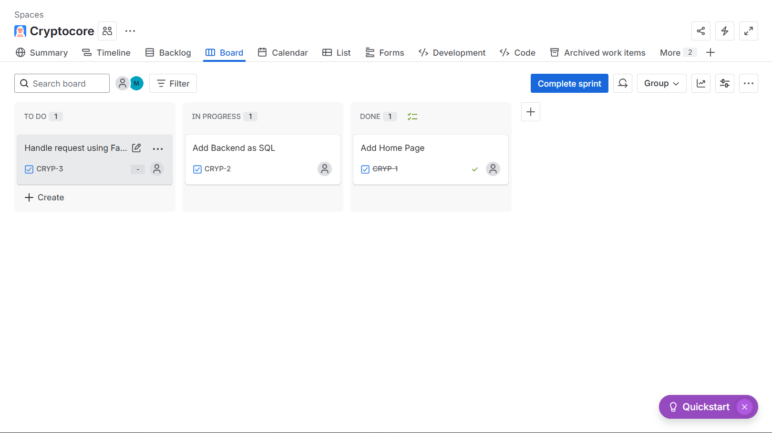

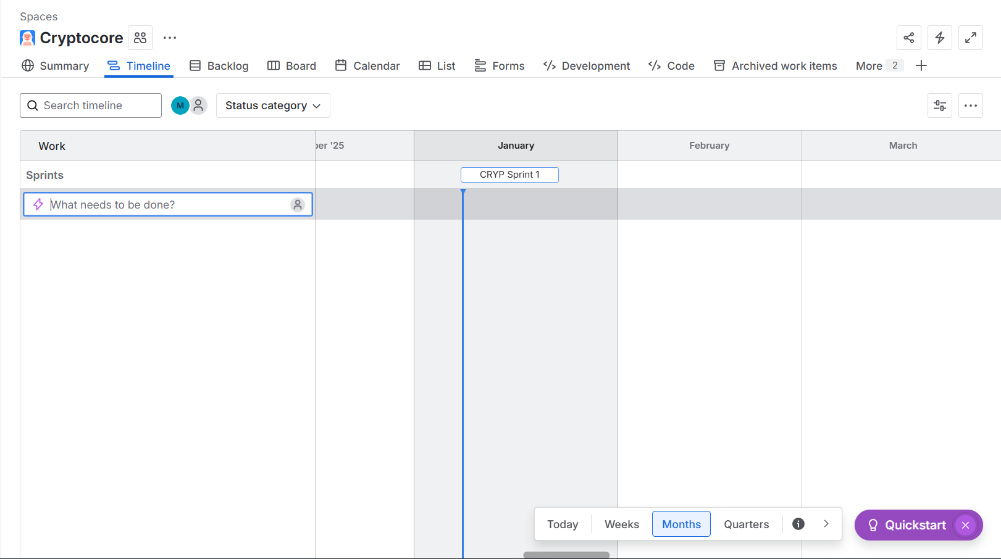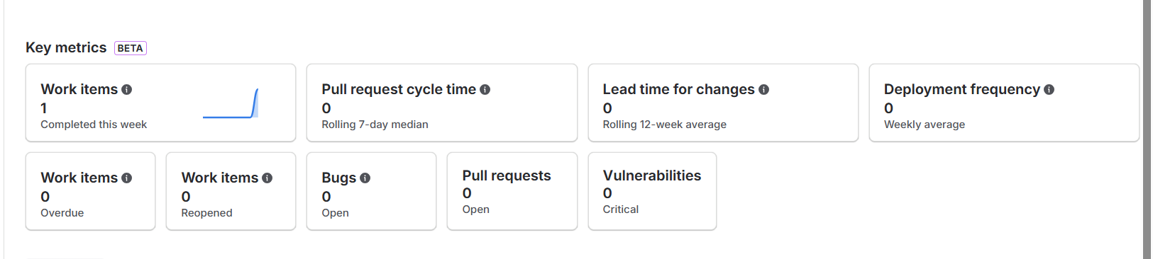

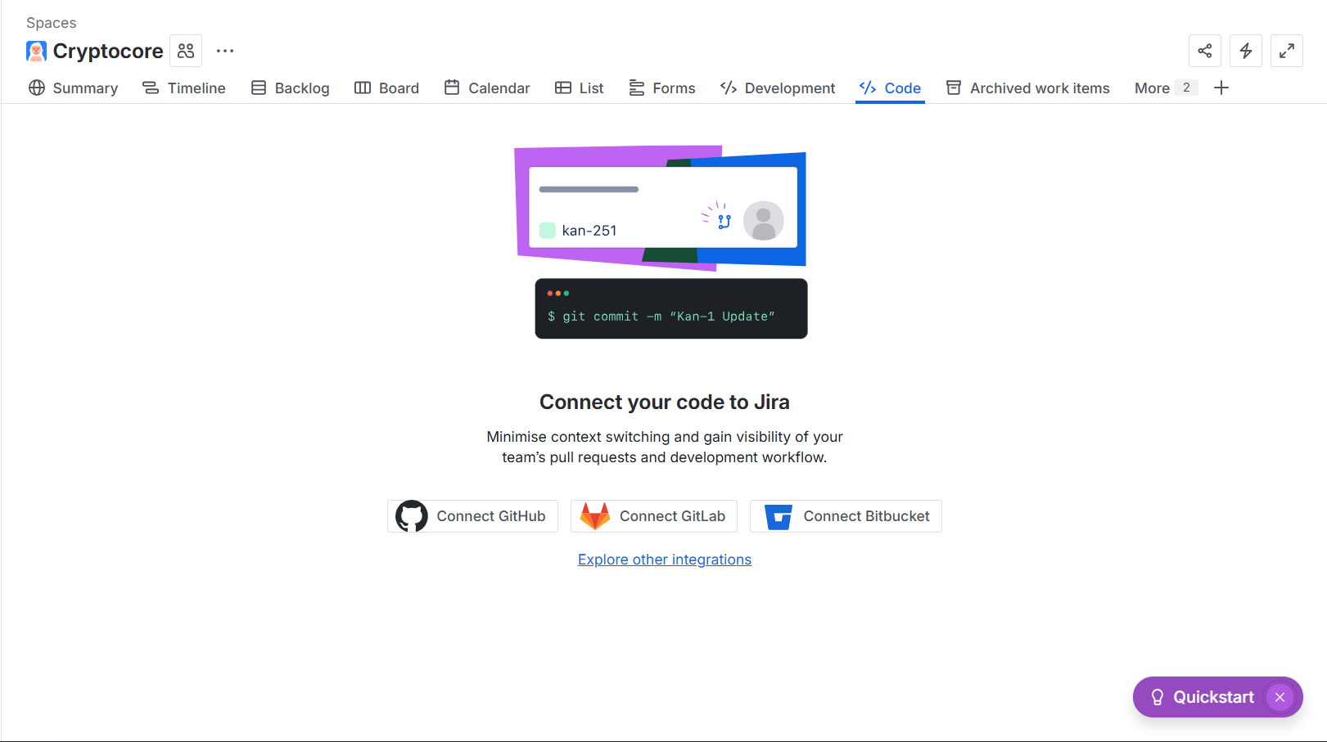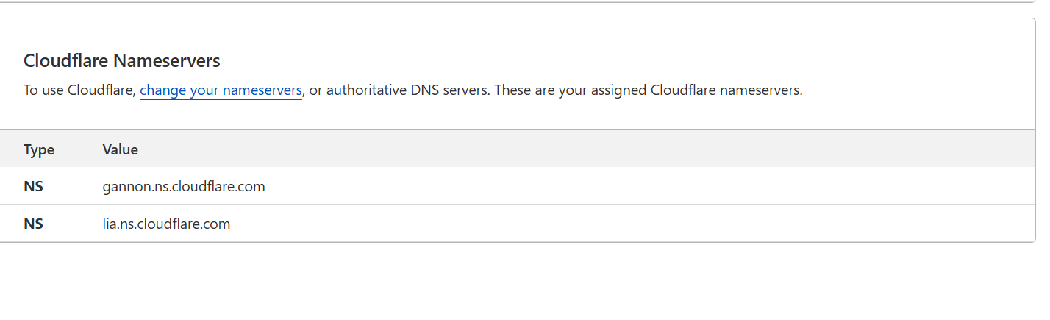

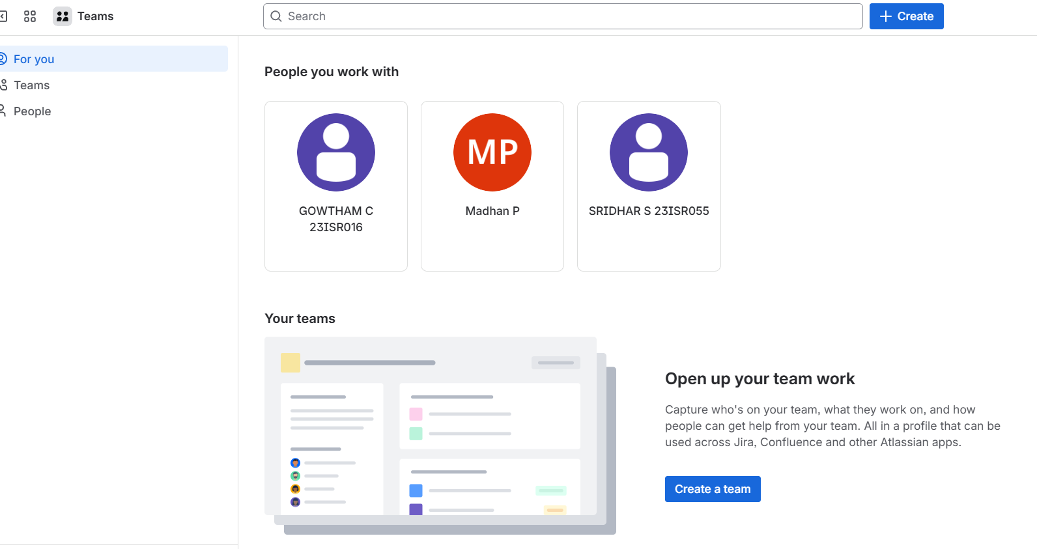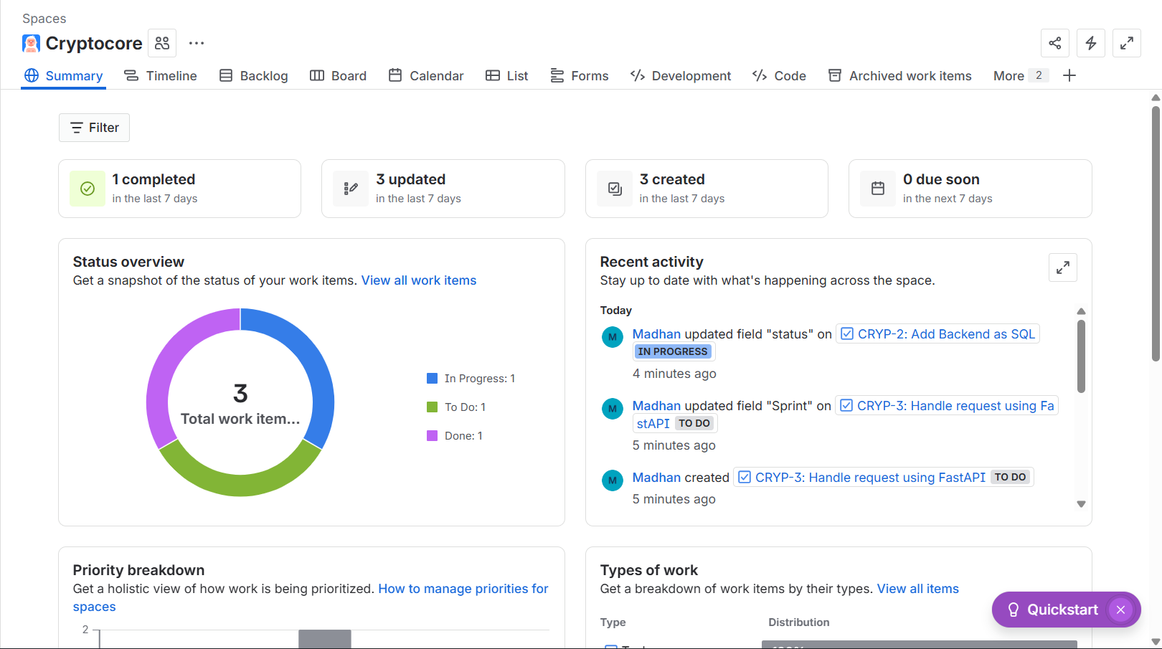

RESULT:
Thus,theJiraaccountwassuccessfullycreatedandconfigured,allowingeffectiveproject and task management.

EX NO:
DATE: INSTALLATIONOFVIRTUALBOX

AIM:
ToinstallUbuntuoperatingsysteminOracleVMVirtualBoxusinganISOimage and verify the installation using terminal commands.

PROCEDURE:

- PowerONthepersonalcomputerandlogintotheWindowsoperatingsystem.
- Insertthependrivecontaining theUbuntu ISOimageintothe system.
- OpenOracleVMVirtualBoxfromthedesktopor Start menu.

- Inthe VirtualBoxManager,create anewvirtualmachine.
- ConfigurethevirtualmachinebyselectingLinuxastheoperatingsystemtypeand Ubuntu as the version.
- OpenSettings→StorageandattachtheUbuntuISOimagebybrowsingtothe
pendrivelocation.

- ClickOKtosavethe configurationandthenclickStart tobootthevirtual machine.
- WaitfortheUbuntuinstallertoloadandcompletetheinstallationbyfollowingthe on-screen instructions.
- Afterinstallation,allowthevirtualmachinetorestartuntiltheUbuntuloginscreen appears.
- Entertheusernameand passwordto log into theUbuntu desktop environment.

- OpentheTerminalapplicationfromtheApplicationsmenuorbyusingthe shortcut.
- Runlsb_release-atoverify theUbuntu OSdetailsanddf -hto viewdisk usage.
- Runsudoaptupdate,entertheadministratorpasswordwhenprompted,andverifythat the system updates successfully and functions properly in VirtualBox.

PROJECTTASKOVERVIEW:
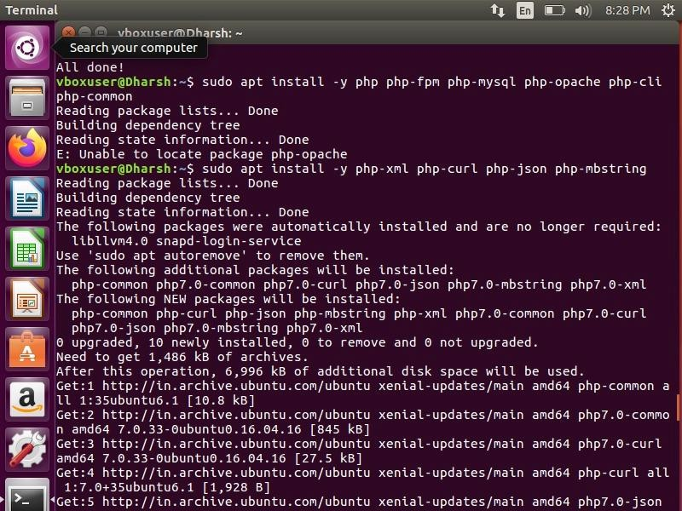

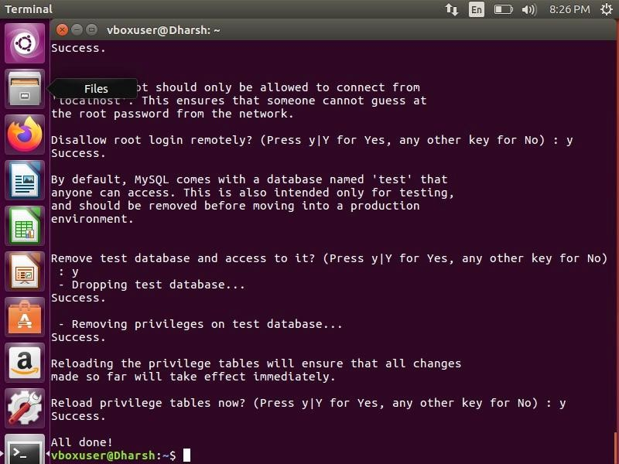

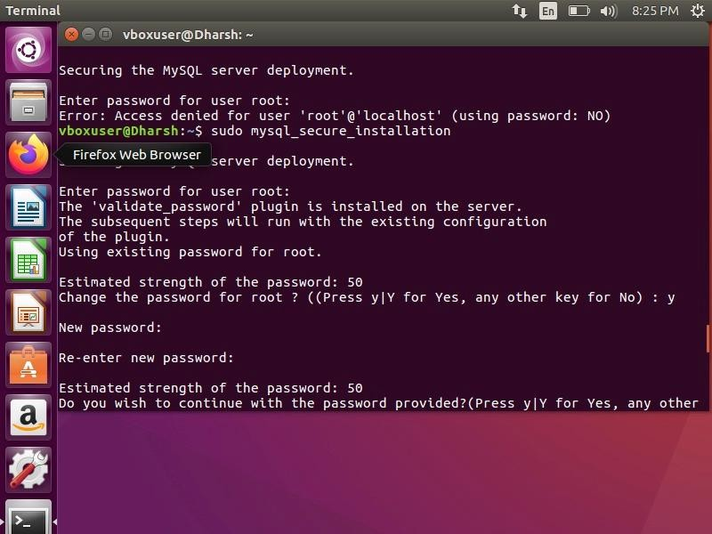

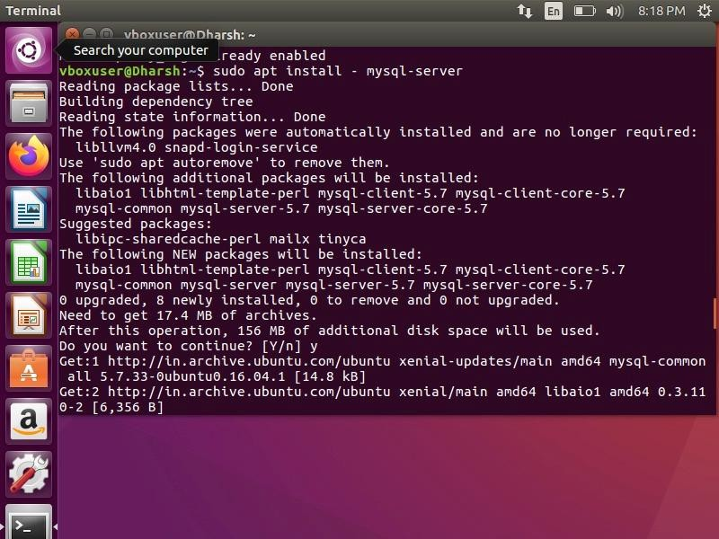

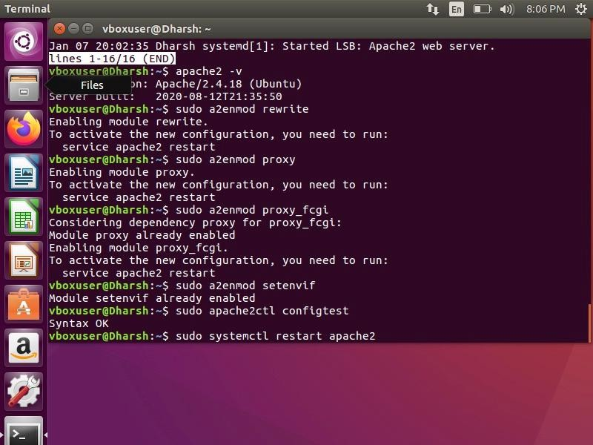

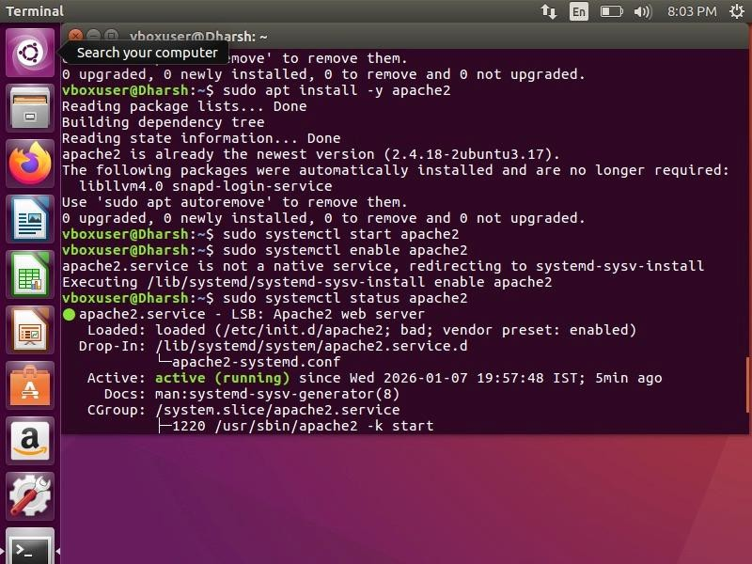

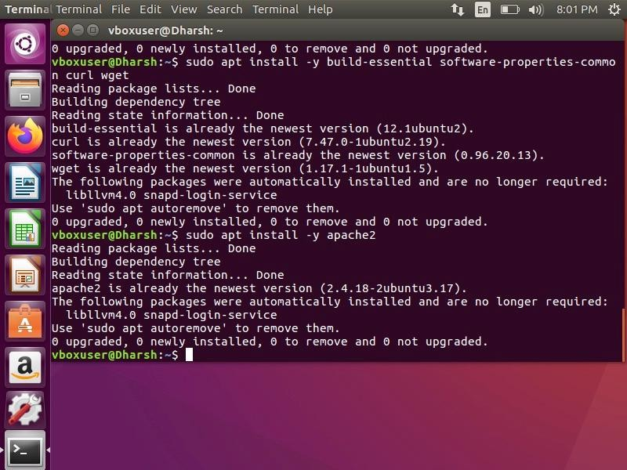

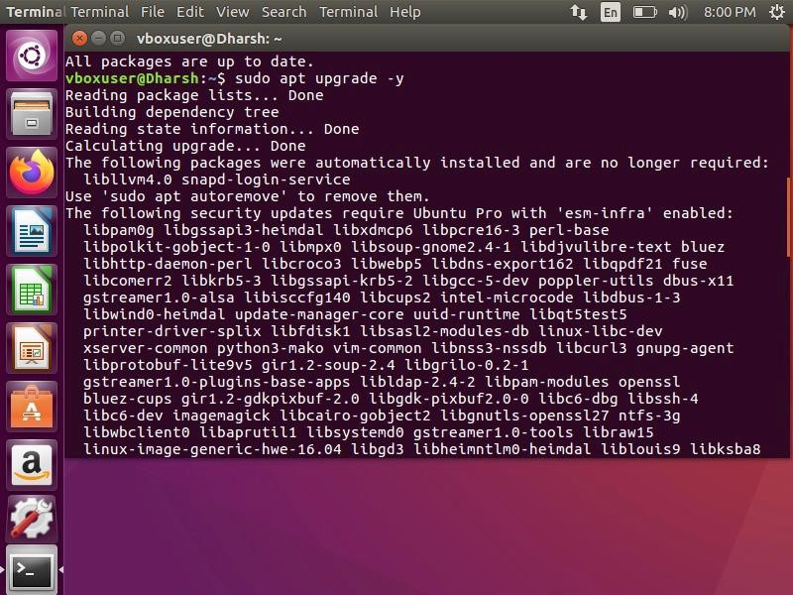

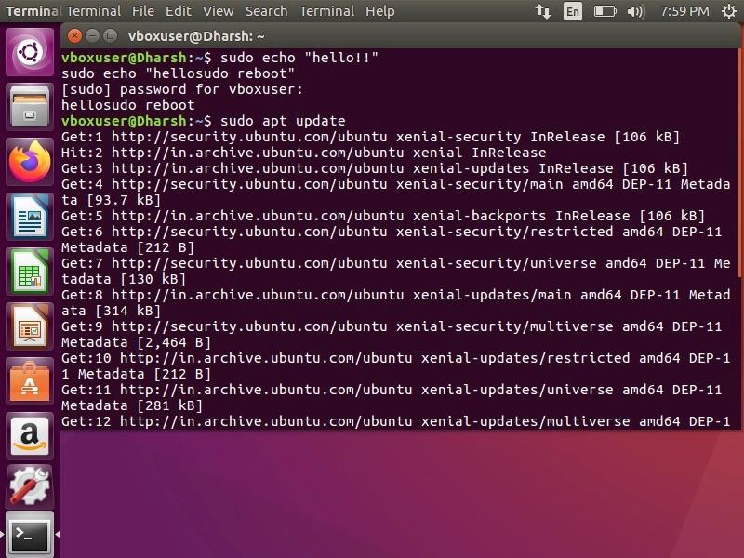

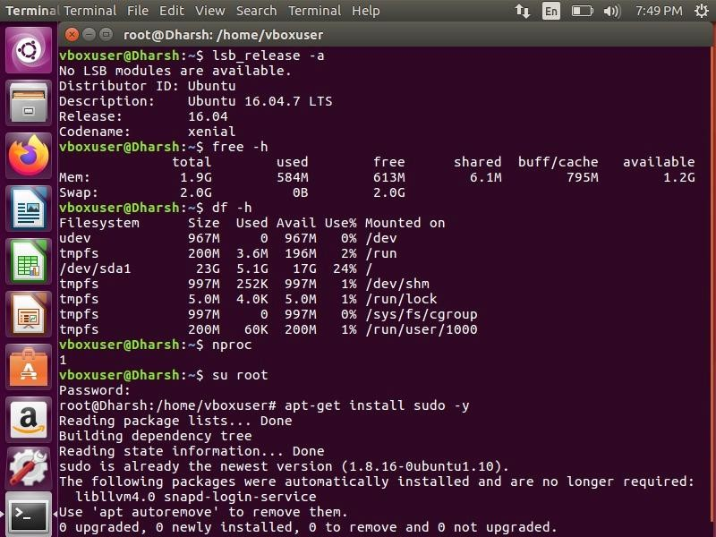

RESULT:
Thus,theUbuntuoperatingsystemwassuccessfullyinstalledinOracleVM VirtualBox and the system was verified to be functioning properly.

EX NO:
DATE: GITBASEDCOMMANDS

AIM:
ToinstallandconfigureGitandGitHubforversioncontrolandperformingbasicGit operations.

PROCEDURE:

- Gitwasfirstinstalledonthesystem,andtheinstallationwasconfirmedbychecking the Git version using the git --version command.
- Afterinstallation,the Gitusername and emailwereconfigured globallysothat all
commitscouldbeproperlylinkedtotheuser’sGitHub account.
- AnewpublicrepositorywasthencreatedonGitHubwithoutinitializingaREADME file to avoid conflicts with the local repository.
- Next,aprojectfolderwascreatedonthelocalsystemandopenedusingGitBashfor executing Git commands.
- ThecreatedprojectfolderwasinitializedasalocalGitrepositoryusingthegitinitcommand.
- AREADMEfilewascreatedinsidetherepositorytoprovidebasicinformationabout the project.
- TheREADMEfilewasaddedtothestagingareaandcommittedtothelocal repository to record the initial version of the project.
- ThelocalGitrepositorywasconnectedtotheremoteGitHubrepositoryusingthe repository URL.
- Thedefaultbranchwasrenamedtomain,andtheprojectfileswerepushedtoGitHub successfully.
- Finally,anewfeaturebranchwascreatedandpushedtoGitHubtounderstandbranch creation and management.

PROJECTTASKOVERVIEW:

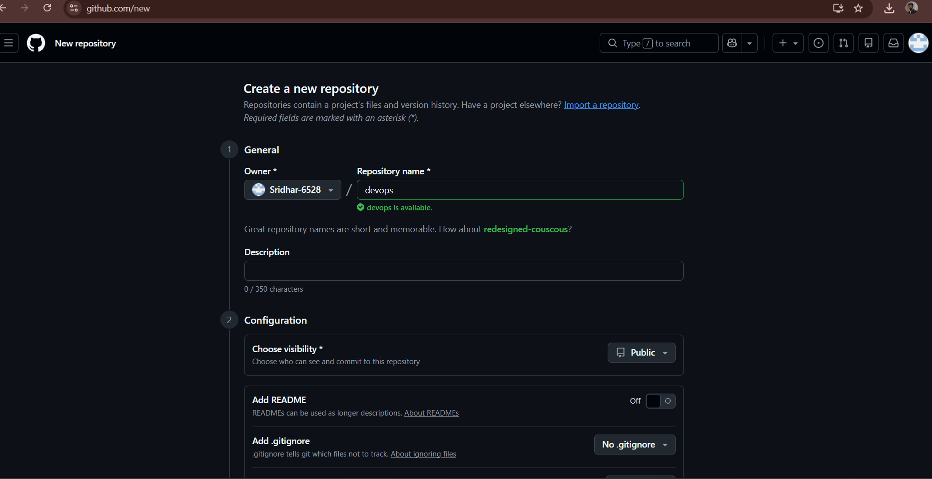

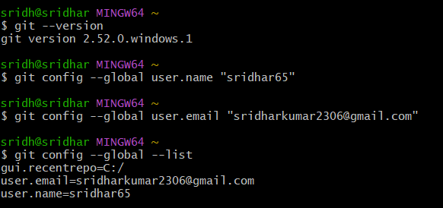

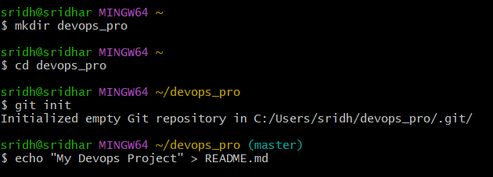

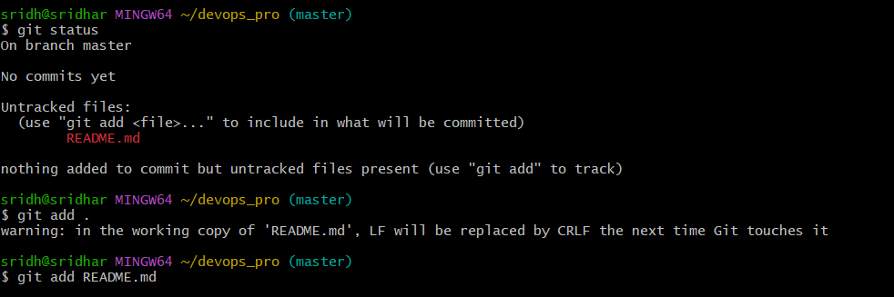

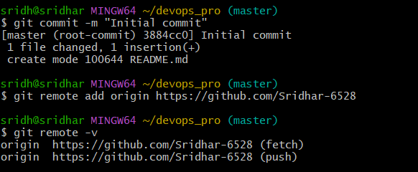

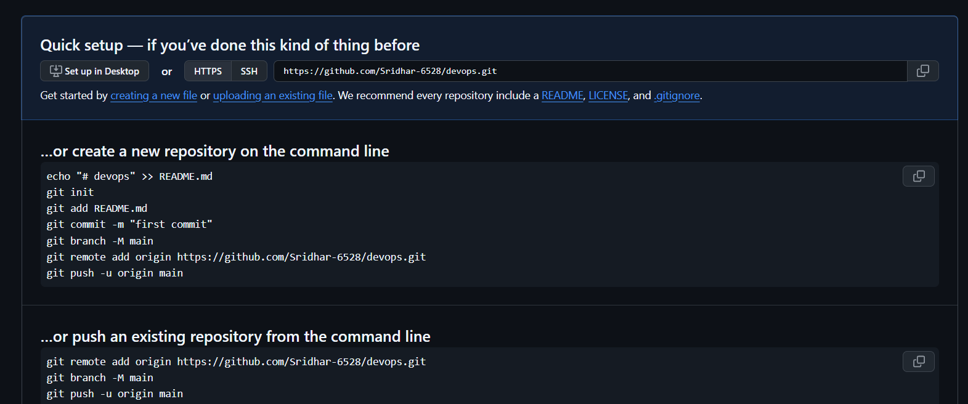

RESULT:
TheexperimentwassuccessfullycompletedandbasicGitandGitHuboperations were performed for version control and collaboration

